California State University, Sacramento
The College of Engineering and Computer Science

CPE 166 Advanced Logic Design

1. Complete the waveform for the hardware design below. assign temp1 = a & b;
assign c = temp1;
assign d = a | b;

always@(posedge clk)
begin

end
e <= d;

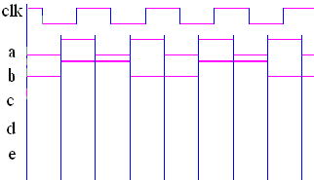

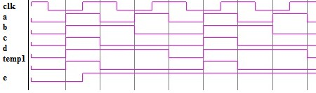Solution:
2. Write Verilog program and testbench for this circuit.
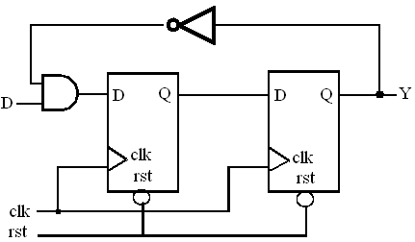

module prob2(clk, d, rst, y);
input clk, d, rst ;
output y; reg y, n; wire m;

assign m = d & (~y);

always@(posedge clk or negedge rst)
begin if(~rst) begin
n <= 0; y <= 0;
end else begin
n <= m; y<= n;
end end

endmodule
//////////////////////////////////////////////////////////
module prob2_tb; reg clk, d, rst; wire y;

prob2 uut(clk, d, rst, y);

initial clk = 0;
always #10 clk = ~clk;

initial begin
rst = 0; d = 0;
#16 rst = 1;
#10 d = 1;
#30 d = 0;

end
#200 $stop;
endmodule

//////////////////////////////////////////////////////////

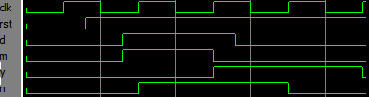

3. Describe the following circuit in Verilog. Write testbench and show simulation waveform.
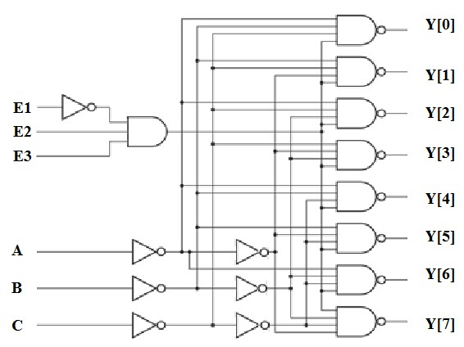

module prob3(E1, E2, E3, A, B, C, Y);
input A, B, C, E1, E2, E3;
output [7:0] Y;
wire M;

assign M = ~E1 & E2 & E3;
assign Y[0] = ~((~C & ~B & ~A) & M); assign Y[1] = ~((~C & ~B & A) & M); assign Y[2] = ~((~C & B & ~A) & M); assign Y[3] = ~((~C & B & A) & M); assign Y[4] = ~(( C & ~B & ~A) & M); assign Y[5] = ~(( C & ~B & A) & M); assign Y[6] = ~(( C & B & ~A) & M); assign Y[7] = ~(( C & B & A) & M);

endmodule
module prob3_tb;

reg E1, E2, E3, A, B, C;
wire [7:0] Y;

prob3 uut(E1, E2, E3, A, B, C, Y);

initial begin
{E1, E2, E3 } = 3'b111;
{C, B, A } = 3'b111;

#10 {E1, E2, E3 } = 3'b011;
{C, B, A } = 3'b000;

#10 {C, B, A } = 3'b001;
#10 {C, B, A } = 3'b010;
#10 {C, B, A } = 3'b011;
#10 {C, B, A } = 3'b100;
#10 {C, B, A } = 3'b101;
#10 {C, B, A } = 3'b110;
#10 {C, B, A } = 3'b111;
#50 $stop;
end endmodule
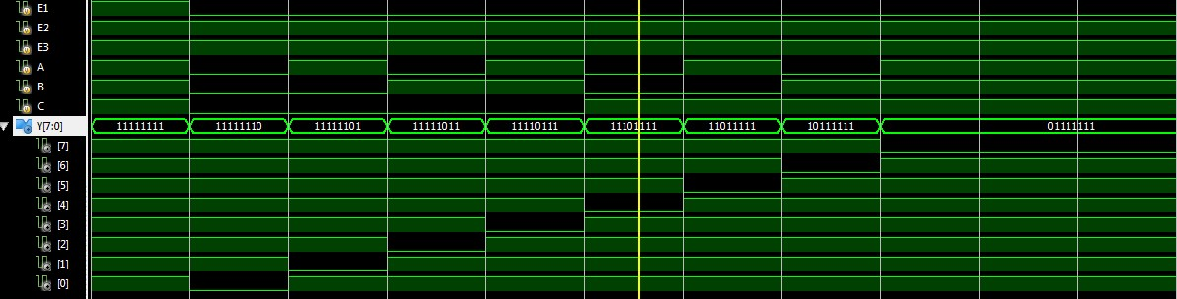
4. Design 3-bit Ripple Carry Adder circuit using hierarchical design method and write testbench in
Verilog.

module fa( a, b, cin, cout, s );

input a, b, cin;
output cout, s;

assign s = a ^ b ^ cin;
assign cout = (( a ^ b ) & cin ) | ( a & b );

endmodule

module rca3(a, b, cin, cout, s);

input [2:0] a, b; input cin; output [2:0] s; output cout;

wire [1:0] m;

fa g1(.a(a[0]), .b(b[0]), .cin(cin), .cout(m[0]), .s(s[0] ) ); fa g2(.a(a[1]), .b(b[1]), .cin(m[0]),.cout(m[1]), .s(s[1] ) ); fa g3( a[2], b[2], m[1], cout, s[2] );
endmodule module rca3_tb; reg [2:0] a, b;
reg cin;
wire [2:0] s;
wire cout;

rca3 uut(a, b, cin, cout, s);

initial begin

end

a = 0; b= 0; cin = 0;
#10 a = 4; b= 5;
#10 a = 6; b= 6;
#10 a = 0; b= 2; cin = 1;
#10 a = 3; b= 3;
#10 a = 5; b= 2;
#20 $stop;

endmodule

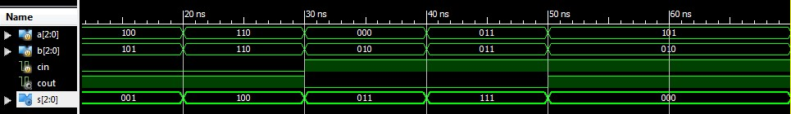

5. Design 4-bit left shift registers in Verilog with serial data input and serial data output. module shift_L4(clk, din, dout);
input clk, din;
output dout; reg [3:0] q; assign dout = q[3];
always@(posedge clk)
begin

//q <= { q[2:0], din };
q[3] <= q[2]; q[2]<= q[1]; q[1] <= q[0]; q[0] <= din; end

endmodule

6. Design 4-bit right shift registers in Verilog with serial data input and serial data output. module shift_R4(clk, din, dout);
input clk, din;
output dout;

reg [3:0] q;

assign dout = q[0];

always@(posedge clk)
begin

q <= { din, q[3:1] };
end endmodule

7. Design the following final state machine in Verilog. (1)
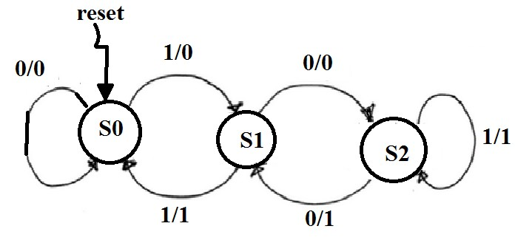

module fsm7 ( clk, reset, a, y );
input clk, reset, a;
output y;
reg y;

parameter s0 = 2'b00, s1=2'b01, s2=2'b10;

reg [1:0] cs, ns;

always@(posedge clk or posedge reset)
begin if(reset)
cs <= s0;
else
cs <= ns;
end

always@(cs or a)
begin case(cs)
s0: if(a) ns = s1;
else ns = s0; s1: if(~a) ns = s2; else ns = s0;
s2: if(a) ns = s2;
else ns = s1;
default: ns = s0;
endcase end
always@(cs or a)
begin case(cs)
s0: y = 0;
s1: if(a) y = 1;
else y = 0; s2: y = 1; default: y = 0;
endcase end

endmodule

(2).
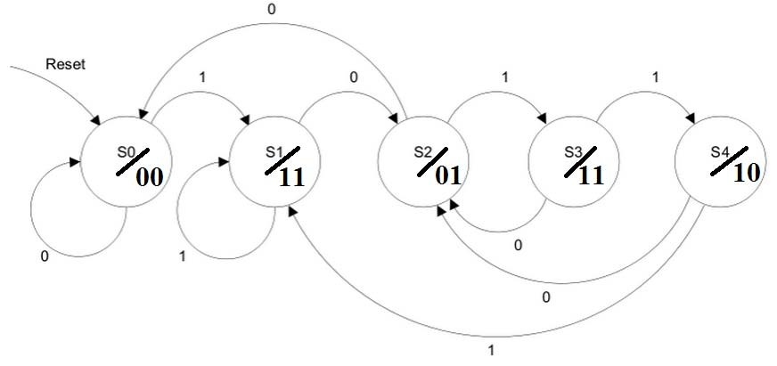

module fsm8 ( clk, reset, a, y );
input clk, reset, a;
output [1:0] y;
reg [1:0] y;

parameter s0 = 3'b000, s1=3'b001, s2=3'b010, s3=3'b011, s4=3'b100;

reg [2:0] cs, ns;

always@(posedge clk or negedge reset)
begin if(~reset)
cs <= s0;
else
cs <= ns;
end

always@(cs or a)
begin case(cs)
s0: if(a) ns = s1;
else ns = s0; s1: if(~a) ns = s2; else ns = s0;
s2: if(a) ns = s3;
else ns = s0;
s3: if(a) ns = s4;
else ns = s2;
s4: if(a) ns = s1;
else ns = s2;
default: ns = s0;
endcase end

always@(cs )
begin case(cs)
s0: y = 2'b00;
s1: y = 2'b11;
s2: y = 2'b01;
s3: y = 2'b11;
s4: y = 2'b10;
default: y = 2'b00;
endcase end

endmodule

8. Use Verilog to design a finite state machine to recognize the sequence 0110.

Analysis:
S_idle: does not detect anything
S1: detect 0
S2: detect 01
S3: detect 011
S4: detect 0110

State Table:
 | Current State | A | Next state | Y
 | S_idle | 0 | S1 | 0
 | S_idle | 1 | S_idle | 0
 | S1 | 0 | S1 | 0
 | S1 | 1 | S2 | 0
 | S2 | 0 | S1 | 0
 | S2 | 1 | S3 | 0
 | S3 | 0 | S4 | 1
 | S3 | 1 | S_idle | 0
 | S4 | 0 | S1 | 0
 | S4 | 1 | S2 | 0

Final Solution:

State Diagram:

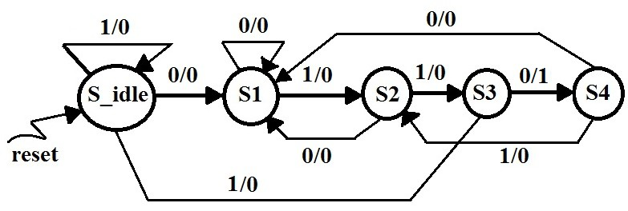

module fsm_detector(reset, clk, a, y);
input reset, a, clk;
output y;
reg y;

parameter s_idle = 3'b000, s1=3'b001, s2=3'b010, s3=3'b011, s4=3'b100;
reg [2:0] cs, ns;

always@(posedge clk or posedge reset)
begin
if(reset) cs <= s_idle;
else cs <= ns;
end

always@(cs or a)
begin case(cs)
s_idle: if(a) ns = s_idle;
else ns = s1;
s1: if(a) ns = s2;
else ns = s1;
s2: if(a) ns = s3;
else ns = s1;
s3: if(~a) ns = s4;
else ns = s_idle;
s4: if(a) ns = s2;
else ns = s1; default: ns = s_idle; endcase
end

always@(cs or a)
begin case(cs)
s_idle: y = 0; s1: y = 0; s2: y = 0;
s3: if(~a) y = 1;
else y = 0; s4: y = 0; default: y = 0; endcase
end endmodule

